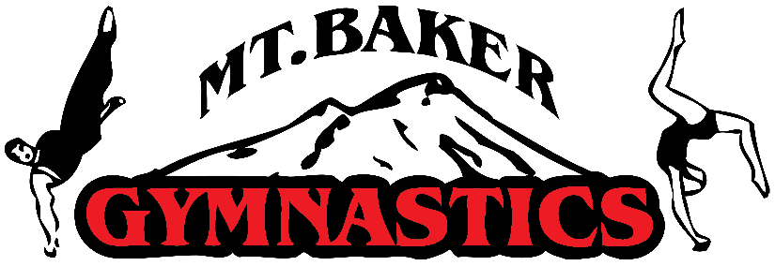

  - Climb for Cubes Fundraiser
Local Business Sponsorship Packages
This July, Coach Gordy and his top gymnast, 16-year-old Calvin Tomsic, will be climbing
Mt. Baker together to challenge themselves physically and mentally, heal emotionally, and strengthen the bond between coach and student. We’ll be using this climb as a fundraiser to help us buy new covered foam cubes that will be cleaner, healthier, and last longer. We use the foam pits for all levels of gymnastics daily, as they help our athletes learn to flip and fall safely, and this is your chance to sponsor one of our two foam pits!
We have 150-300 families in and out of our gym at any given time, so this is a great opportunity to sponsor a good cause for our gymnastics community, support a fellow local business, while advertising your business to hundreds of potential local customers.
Our Fundraising Goal: $5,000
Sponsorship Levels | Banners
Basecamp: $100-$299 | Small (2’x5’) banner for 1 year
North Face: $300-$499 | Medium (3’x6’) banner for 1 year
Summit: $500+ | Large (3’x8’) banner for 1 year

All sponsors will receive cross promotion on our website and social media. After the climb we will host a free open gym event to celebrate our success, document the climb with video footage, and allow our sponsors to set up tables to network, advertise, and hand out marketing materials to potential customers.
THANK YOU FOR HELPING US REACH THE PEAK OF OUR GOALS!

